**Exercise**

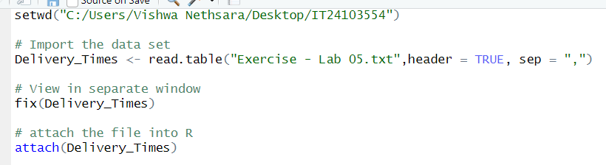1.Import the dataset (’Exercise – Lab 05.txt’) into R and store it in a data frame called ”Delivery Times”.

2. Draw a histogram for deliver times using nine class intervals where the lower limit is 20 and upper limit is 70. Use right open intervals.

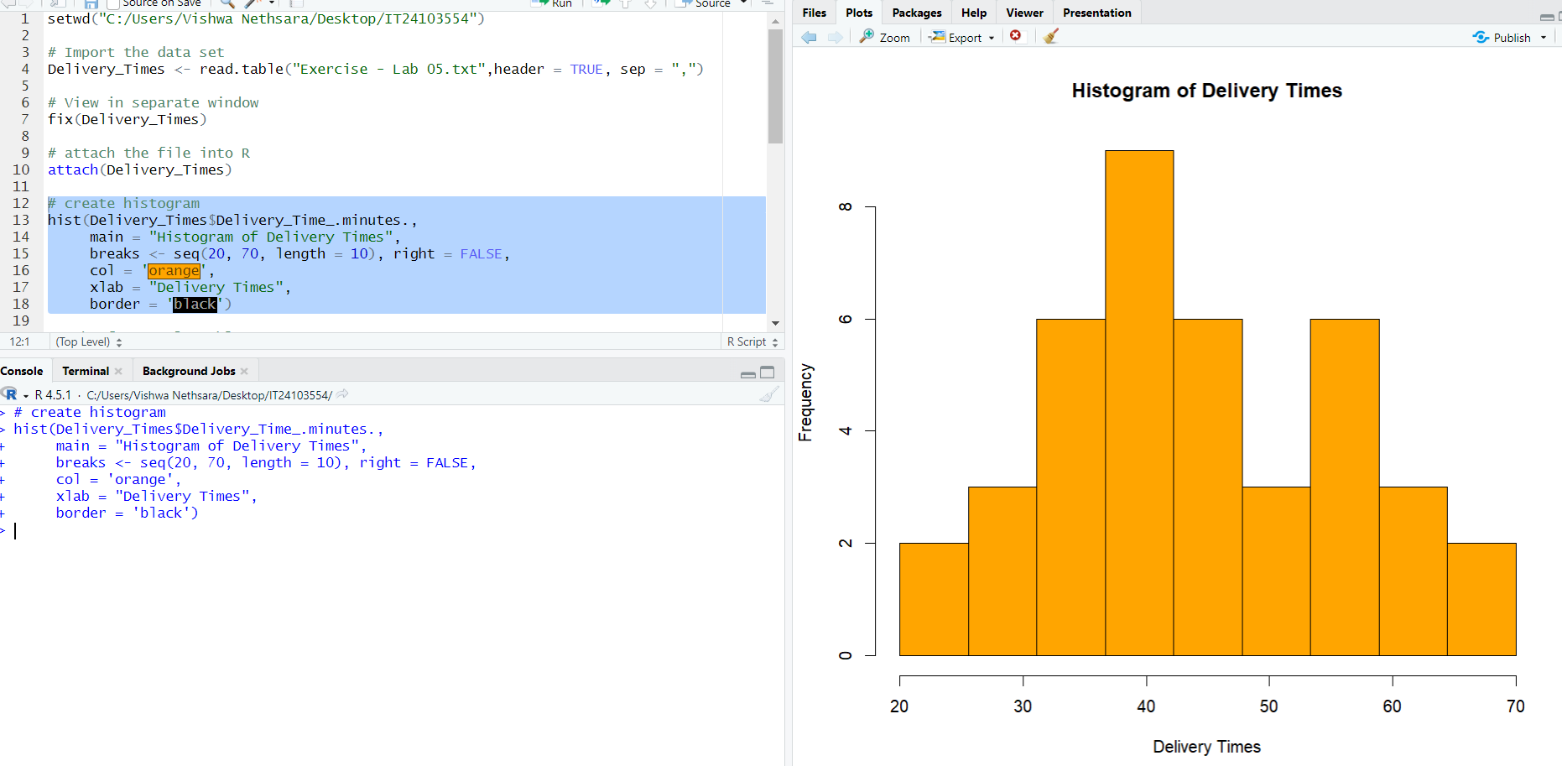

4. Draw a cumulative frequency polygon (ogive) for the data in a separate plot.

